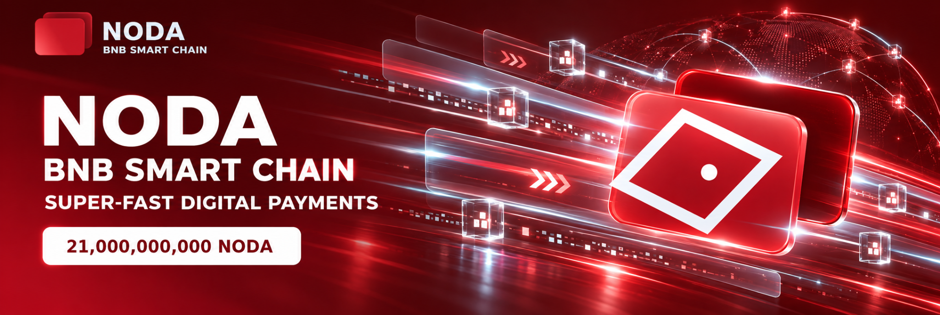
NODA
TOKENOMICS v1.1
Issuance, Allocation, Vesting and Liquidity Policy
BNB Smart Chain • Fixed Supply • 21,000,000,000 NODA
Parameter | Value | Status
Token | NODA | Confirmed
Network | BNB Smart Chain (BSC) | Confirmed
Contract | 0x34027b8aab4daf79df81b470df05357c465bada6 | Owner-confirmed
Total Supply | 21,000,000,000 NODA | Fixed
Decimals | 18 | Confirmed
Source Verification | BscScan Exact Match | Confirmed
Creator / Deployer | 0x22d67ed1B816Cf792702C512b93CC2f1b8eDdbFe | Owner-confirmed
Version 1.1 • September 10, 2026

1. Core Principles
NODA uses a fixed-supply model on BNB Smart Chain. The total supply is permanently capped at 21 billion NODA. According to the verified contract source code, no public mint function is available.
- No issuance beyond 21 billion NODA is provided for.
- The contract has no owner/admin, blacklist, pause, transfer tax/fee or upgradeability functions.
- Transfers between project wallets do not constitute new issuance.
- Token allocation and actual circulating supply are treated as separate concepts.
- Material movements from project wallets are subject to separate monitoring by NODA Control.

2. Total Supply Allocation
Allocation | Amount (NODA) | Share | Public Label
Treasury | 8,000,000,000 | 38.0952% | nodatreasury.bnb
Reserve | 7,000,000,000 | 33.3333% | noda-reserv.bnb
Liquidity | 3,000,000,000 | 14.2857% | noda-liquidity.bnb
Ecosystem | 1,500,000,000 | 7.1429% | noda-ecosystem.bnb
Team | 999,999,011.5577 | 4.7619% | noda-team.bnb
Strategic / Operational Reserve | 499,998,978.9017 | 2.3809% | noda-treasury1.bnb
As of the baseline date, almost the entire supply is held across dedicated project addresses. This allocation describes the intended use of issued tokens and does not mean that the entire supply is freely circulating on the market.

3. Project Wallet Registry
Role | Address | Space ID
Treasury | 0x3DaeE1CC81497F060AE41f3460C03fD493279180 | nodatreasury.bnb
Reserve | 0xE16aEdc8376c5A00E62AdaA1555A3AFd6308bA61 | noda-reserv.bnb
Liquidity | 0xe6dEbc238e255E68eE7f49d59F8B49E1e37E0465 | noda-liquidity.bnb
Ecosystem | 0xc4479E47d85c5E8d396ad2f66749151D400804cb | noda-ecosystem.bnb
Team | 0x34cF0E4768b09d42cF0045F974c0240f5C11d50 | noda-team.bnb
Strategic / Operational Reserve | 0x95f074CFB5d9032Cf1AD3C5A7394C2D54e41D133 | noda-treasury1.bnb

4. Approved Allocation Policy

4.1 Treasury — 8 Billion NODA
The Treasury supports the long-term development of NODA, including infrastructure, technical development, legal and compliance work, marketing, integrations, strategic partnerships and other project-related expenses.
- Transactions above 100 million NODA should be accompanied by an internal or public explanation of purpose.
- Transactions of 210 million NODA or more (1% of total supply) are classified as material and monitored by NODA Control.

4.2 Reserve — 7 Billion NODA
The Reserve is a long-term strategic reserve and is not intended for ordinary recurring operating expenses.
- Permitted uses include major partnerships, infrastructure expansion, additional liquidity, ecosystem protection and other exceptional project needs.
- A movement of 210 million NODA or more is treated as a material reserve event and should be accompanied by an explanation of its purpose.

4.3 Liquidity — 3 Billion NODA
The 3 billion NODA allocation is the maximum strategic reserve available for market-liquidity development. It does not imply that the full amount will be deposited into DEX liquidity at once.
- Liquidity is deployed gradually according to demand, trading activity and market depth.
- The initial primary trading pair is NODA/USDT on PancakeSwap V3.
- Major liquidity withdrawals and material LP parameter changes are monitored and, when appropriate, publicly disclosed.

4.4 Ecosystem — 1.5 Billion NODA
The Ecosystem allocation is intended for integrations, incentives, partnerships, grants, community programs, airdrops and other initiatives that support ecosystem development.
- A single program should not use more than 5% of the Ecosystem allocation — 75 million NODA — without a separate project decision or public announcement.

4.5 Team — Approximately 1 Billion NODA
The Team allocation is intended to align the long-term interests of the project team with NODA development. The approved model is a 12-month full lock-up followed by 24 months of linear vesting.
Period | Rule
First 12 months | 0% of the Team allocation is scheduled for release
Following 24 months | Linear vesting of approximately 1/24 of the Team allocation per month
Total schedule | 36 months from the official NODA launch
The 12-month lock-up begins on the official NODA launch date. For public verifiability, the start date is the date of the official launch announcement published through the project’s official channels. The same calendar date should be used consistently in Tokenomics, the Whitepaper and the official project announcement.

4.6 Strategic / Operational Reserve — Approximately 500 Million NODA
The wallet noda-treasury1.bnb is formally designated as the Strategic / Operational Reserve.
- Purpose: time-sensitive technical tasks, infrastructure testing, listing procedures, integrations, service expenses and limited strategic operations.
- This allocation remains organizationally separate from the main Treasury and the long-term Reserve.

5. Circulating Supply Policy
For NODA, total supply and circulating supply are not the same metric. The fact that tokens exist on-chain does not automatically mean that they are freely available to the market.
- Total supply: fixed at 21,000,000,000 NODA.
- Project allocation: tokens held in Treasury, Reserve, Liquidity, Ecosystem, Team and Strategic / Operational Reserve wallets.
- Active DEX liquidity: only the amount actually deposited into live LP positions.
- Circulating supply: tokens that are actually available to the public market and are not subject to active project restrictions.
Until a formal circulating-supply methodology is adopted, the project should not publicly present all 21 billion NODA as freely circulating supply.

6. NODA Liquidity
Parameter | Current Baseline
DEX | PancakeSwap V3
Pair | NODA / USDT
Pool Contract | 0x2e8225eF29e0A2C928B9feFD53f9B6F359938Cf1
Position ID | #7381143
Fee Tier | 0.01%
Active Range | 0.979–0.981 USDT per NODA
Baseline Price | ≈ 0.98024 USDT per NODA
The 3 billion NODA balance allocated to noda-liquidity.bnb is a liquidity reserve allocation. Reporting should distinguish this amount from the actual quantity of tokens deposited into a live LP position.

7. Material Event Monitoring
- Movement of ≥210,000,000 NODA from any project wallet.
- Change or loss of BscScan Exact Match verification.
- Mismatch in total supply, ticker or contract address on major trackers.
- Material reduction in liquidity or movement of the active V3 position outside the 0.979–0.981 range.
- New scam / malicious / honeypot / unsafe flag.
- Change in verification status on CoinMarketCap, CoinGecko or other key platforms.

8. Official Sources
Source | Address
Website | https://nodabank.ru/en
Telegram | https://t.me/NODA_Token
X | https://x.com/NodaToken
BscScan | https://bscscan.com/address/0x34027b8aab4daF79DF81B470df05357C465BaDA6
GeckoTerminal | https://www.geckoterminal.com/bsc/pools/0x2e8225ef29e0a2c928b9fefd53f9b6f359938cf1
CoinMarketCap DEX | https://dex.coinmarketcap.com/token/bsc/0x34027b8aab4daf79df81b470df05357c465bada6/

9. Risks and Limitations
- Concentration: a significant share of the supply is held in project addresses, which may increase automated risk scores used by third-party services.
- Liquidity: active DEX liquidity remains small relative to total supply and is deployed within a narrow V3 range.
- Operational risk: fixed supply does not eliminate the risk of unauthorized access to project wallets.
- Market metrics: TVL, volume, APR, price and market capitalization are dynamic and may be calculated differently across platforms.
- The vesting policy is meaningful only if the project team follows the stated schedule and publicly records the launch date in a verifiable way.

10. Version 1.1 Status
Version 1.1 formalizes the core policies for Treasury, Reserve, Liquidity, Ecosystem, Team and Strategic / Operational Reserve. The key change from v1.0 is the formal Team vesting policy: a 12-month lock-up from the official NODA launch followed by 24 months of linear vesting.
Before publication of the full Whitepaper, the following should be synchronized with this Tokenomics document: the official launch date, Team vesting schedule, project-wallet purposes, circulating-supply methodology and live-liquidity parameters.

Disclaimer
This document describes the issuance structure and internal allocation policy of NODA. It is not investment advice, a promise of price, yield, liquidity or listing, and should not be interpreted as a guarantee of the token’s future market value.

